1. Classical Theory of Interest Rate

Alfred Marshall is generally considered the first economist to combine interest rates, saving, and investment together to analyze the determination of interest rates. In his famous book *Principles of Economics*, he wrote: ‘Interest, being the price paid for the use of capital in any market, tends towards an equilibrium level such that the aggregate demand for capital in that market, at that rate of interest, is equal to the aggregate stock forthcoming there at that rate’. This idea underlies the classical theory of interest rate that based its analysis of interest rates on real factors.

According to classical economists, there are two main real factors that determine interest rates: saving and investment. Saving could be seen as postponed consumption, which is an increasing function of interest rates. As interest rate increases, the marginal benefit of postponing consumption will dominate the marginal loss of consumption reduction and thus the total amount of saving will increase. Investment is the demand for capital derived from business opportunities. The increase of interest rate will lead to higher financing costs, making some of the less profitable business opportunities no longer worthy of investing. That means investment is a decreasing function of interest rates. For a given interest rate level, if the amount of saving is higher than investment, saving suppliers will be willing to cut down interest rates; similarly, if the amount of investment is higher than saving, investors will be willing to raise interest rates to fund profitable business. Eventually, both forces will drive the interest rate dynamics to a market equilibrium, which determines the interest rate level for the time being.

There are many factors that will influence the saving and investment curve and cause the shift of market equilibrium. The saving curve is mainly impacted by income level and individuals’ time preference. If income increases or individuals are more willing to trade current consumption for more future consumption, the amount of saving for any given interest rate level will increase, pushing down equilibrium interest rate. The investment curve is determined by profitability of business opportunities. A booming economy, improved business environment and technology revolution will make investment more favorable on any interest rate level. As a result, the investment curve will move to the right and equilibrium interest rate will increase.

The classical theory is criticized for two reasons. First, it is an indeterminate theory. Saving is largely driven by income level. At the same time, investment will contribute to income. This means both drivers of interest rate are dependent on each other so there is no settled equilibrium. Second, it neglects other aspects of interest rates, such as monetary factors.

|  |  |
| --- | --- |
|  | |
|  |  |

1. Liquidity Preference Theory

John Maynard Keynes developed his framework of interest rates determination by maintaining that individuals have preferences for liquidity. Given his assumption that there are only two types of assets: money and bonds, individuals’ level of preference reflects in their demand for money.

In *The General Theory of Employment, Interest and Money*, he described three motives to liquidity preference: transactions motive, precautionary motive and speculative motive. Transactions motive means one reason of holding money is to ‘bridge the interval between the receipt of income and its disbursement’; precautionary motive requires money holding for unexpected expenditure; speculative motive represents the mentality of holding money to invest in more profitable business in the future. When interest rate is low, the opportunity cost of holding money to satisfy these motives is very low as well. As demand for money will increase, we can tell that money demand is a decreasing function of interest rates. On the other hand, Keynes assumed that money supply is totally determined by central banks. This predetermined amount will not be affected by interest rate so money supply will be the same across different interest levels.

Based on this theory, equilibrium interest rate will change when money demand and supply curve shifts. There are two factors relevant to money demand: income and price. As income increases, individuals can hold more money to satisfy their liquidity preferences. As price increases, individuals tend to hold more money to preserve a relatively stable purchasing power. Therefore, increasing income and price will move demand curve to the right and push equilibrium interest rates up. Factors impacting money supply can be rather complicated. To simplify the model, it is taken as a decision exogenously made by central banks. When central banks decide to print more money, money supply curve will shift right, and equilibrium interest rate will decrease.

|  |  |
| --- | --- |
|  | |
|  |  |

The main criticism of the liquidity preference framework was proposed by Milton Friedman. He recognized Keynes’s conclusion of decreasing interest rate resulting from increasing money supply but believed this would be correct only when all other conditions remained unchanged. In his opinion, Keynes’s analysis is the liquidity effect of money supply increase. There are three other effects: income effect, price effect and expected inflation effect. Income effect and price effect indicate that income and price will increase with extra money supply and thus will lead to money demand increase and a higher equilibrium interest rate. Expected inflation effect works from an expectation perspective. That is, individuals will expect a higher inflation even when price has not actually increased when more money is supplied. A higher inflation expectation will cause a higher money demand and eventually a higher equilibrium interest rate. The final effect of increasing money supply will depend on the aggregate result of these four effects. In general, liquidity effect will be immediately seen. Income and price effect will follow later. Expected inflation effect could be fast or slow depending on public’s pace of adjusting their inflation expectation.

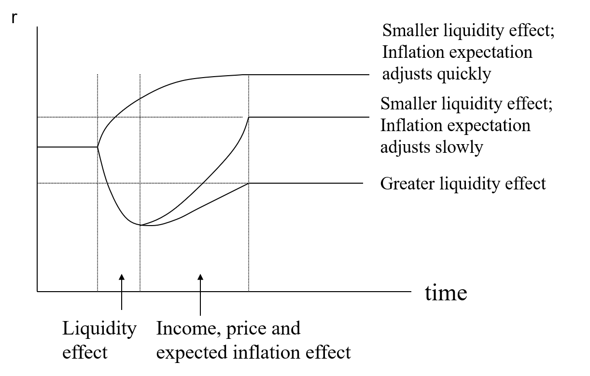

1. The Loanable Funds Theory

Incorporating both the real factors approach by classical economists and the liquidity preference framework by Keynes, Ohlin and Robertson developed a framework based on loanable funds. A broad definition of loanable funds includes all available money in the market. To simplify the definition, we can write the demand and supply of loanable funds as follows:

Ld＝I(r)＋ΔMd (r), Ls＝S(r)＋ΔMs (r)

Based on the analysis for the first two parts, we can tell that the demand for loanable funds is a decreasing function of interest rate and its supply is an increasing function. All the factors that will impact investment and money demand will also shift the demand curve of loanable funds, which includes profitability of business opportunities, expected inflation and government deficit. On the other hand, factors driving supply curve of loanable funds include income level, individuals’ time preference and risk appetite, and money supply decision made by central banks.